# FINAL DELIVERABLES

# 

# DOCUMENTATION

|  |  |
| --- | --- |
| *DATE* | 19 NOVEMBER 2022 |
| *TEAM ID* | **PNT2022TMID27179** |
| *TEAM MEMBERS* | ***RAJARAJAN. L***  ***POOJA. K***  ***HEMALATHA. N***  ***AUSTIN THADATHIL ALEX*** |

# 

# Smart farmer- IoT based smart farming application

**Table of Contents**

1. ***INTRODUCTION*** *3*
   1. *Project Overview 3*
   2. *Purpose 3*
2. ***LITERATURE SURVEY*** *3*
   1. *Existing Problem 3*
   2. *References 3*
3. ***IDEATION & PROPOSED SOLUTION 4***
   1. *Empathy Map Canvas 4*
   2. *Ideation & Brainstroming 5*
   3. *Proposed Solution 8*
   4. *Proposed Solution ﬁt 10*
4. ***REQUIREMENT ANALYSIS*** *11*
   1. *Functional requirement 12*
   2. *Non-Functional requirements 13*
5. ***PROJECT DESIGN 11***
   1. *Data Flow Diagrams 11*
   2. *Solution & Technical Architecture 12*
   3. *User Stories 12*
6. ***PROJECT PLANNING & SCHEDULING*** *16*
   1. *Sprint Planning & Estimation 16*
   2. *Sprint Delivery Schedule 17*
7. ***CODING & SOLUTION*** *18*
   1. *Feature 1 18*
   2. *Feature 2 18*
8. ***TESTING*** *19*
   1. *Test Cases 19*
   2. *User Accepting Testing 21*
9. ***RESULTS*** *22*
   1. *Performance Metrics 22*
10. ***ADVANTAGES & DISADVANTAGES 23***
11. ***CONCLUSION 24***
12. ***FUTURE SCOPE 24***
13. ***APPENDEX 25***

*Source Code 25*

*Github Link 26*

*Demo video Link* 26

# ****INTRODUCTION****

## Project Overview

Plant monitoring is seen as one of the most important tasks in the farming or agriculture based environment. With the inception of Ambient systems, there have been a rise in ambient intelligent based devices. Integration of such an ambient intelligent system with plant monitoring makes farming easier.

## Purpose

The purpose of this project is to give the customer a portal to view the information regarding the agiculture environment. The data will be analysed and information best gardening options for that particular plant will be provided to the user.

# LITERATURE SURVEY

## Existing Problem

Clever irrigation answers are the evolving trend in each day lives. the generation has finished a full circle via giving lower back to irrigation the modern- day developments and techniques which have been evolved. connectivity the usage of present wifi networks the use of the to be had hardwares is one important gain for clever agriculture.

## References

[https://www.google.com/url?sa=t&source=web&rct=j&url=https://www.researchgate.n](https://www.google.com/url?sa=t&source=web&rct=j&url=https%3A//www.researchgate.net/publication/338458451_A_Literature_Survey_on_Internet_of_Things_IoT&ved=2ahUKEwjkwten07X7AhXTILcAHQsJDzkQFnoECAoQAQ&usg=AOvVaw3E-W9SedHxgpn-LaMIK3vF) [et/publication/338458451_A_Literature_Survey_on_Internet_of_Things_IoT&ved=2ahUK](https://www.google.com/url?sa=t&source=web&rct=j&url=https%3A//www.researchgate.net/publication/338458451_A_Literature_Survey_on_Internet_of_Things_IoT&ved=2ahUKEwjkwten07X7AhXTILcAHQsJDzkQFnoECAoQAQ&usg=AOvVaw3E-W9SedHxgpn-LaMIK3vF) [Ewjkwten07X7AhXTILcAHQsJDzkQFnoECAoQAQ&usg=AOvVaw3E-W9SedHxgpn-](https://www.google.com/url?sa=t&source=web&rct=j&url=https%3A//www.researchgate.net/publication/338458451_A_Literature_Survey_on_Internet_of_Things_IoT&ved=2ahUKEwjkwten07X7AhXTILcAHQsJDzkQFnoECAoQAQ&usg=AOvVaw3E-W9SedHxgpn-LaMIK3vF) [LaMIK3vF](https://www.google.com/url?sa=t&source=web&rct=j&url=https%3A//www.researchgate.net/publication/338458451_A_Literature_Survey_on_Internet_of_Things_IoT&ved=2ahUKEwjkwten07X7AhXTILcAHQsJDzkQFnoECAoQAQ&usg=AOvVaw3E-W9SedHxgpn-LaMIK3vF)

[https://www.google.com/url?sa=t&source=web&rct=j&url=https://www.ncbi.nlm.nih.go](https://www.google.com/url?sa=t&source=web&rct=j&url=https%3A//www.ncbi.nlm.nih.gov/pmc/articles/PMC7070544/&ved=2ahUKEwjlj6Tn1LX7AhU0ELcAHQ9VCZYQFnoECCAQAQ&usg=AOvVaw14NcDbHoQFwleyJoe4Z6Ca) [v/pmc/articles/PMC7070544/&ved=2ahUKEwjlj6Tn1LX7AhU0ELcAHQ9VCZYQFnoECC](https://www.google.com/url?sa=t&source=web&rct=j&url=https%3A//www.ncbi.nlm.nih.gov/pmc/articles/PMC7070544/&ved=2ahUKEwjlj6Tn1LX7AhU0ELcAHQ9VCZYQFnoECCAQAQ&usg=AOvVaw14NcDbHoQFwleyJoe4Z6Ca) [AQAQ&usg=AOvVaw14NcDbHoQFwleyJoe4Z6Ca](https://www.google.com/url?sa=t&source=web&rct=j&url=https%3A//www.ncbi.nlm.nih.gov/pmc/articles/PMC7070544/&ved=2ahUKEwjlj6Tn1LX7AhU0ELcAHQ9VCZYQFnoECCAQAQ&usg=AOvVaw14NcDbHoQFwleyJoe4Z6Ca)

# IDEATION & PROPOSED SOLUTION

## Empathy Map Canvas

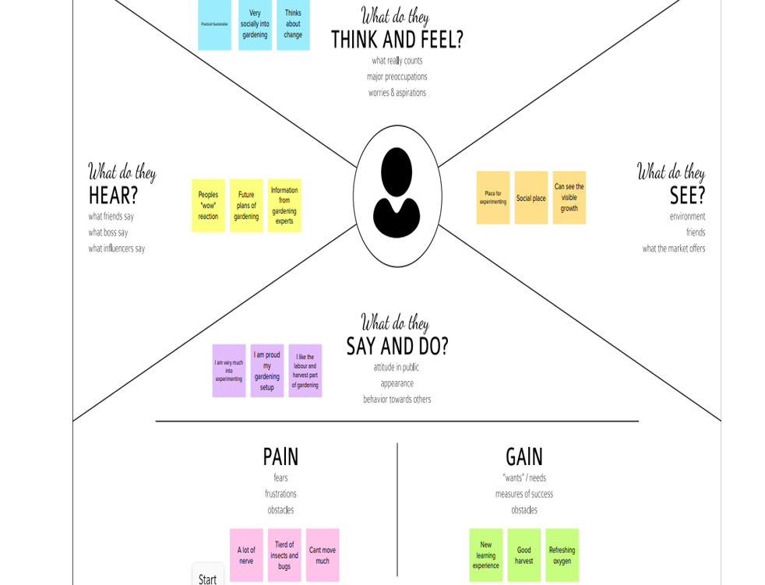

* 1. **Ideation & Brainstorming**

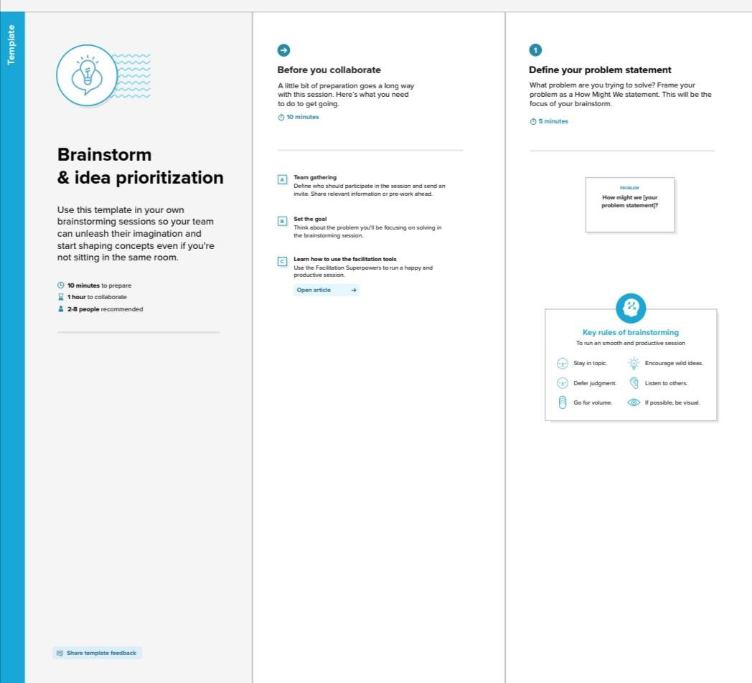

## Proposed Solution

|  |  |  |
| --- | --- | --- |
| **S.No** | **Parameter** | **Description** |
| 1. | **Problem Statement (Problem to be solved**) | To provide efficient decision support system using wireless sensor network which handle different activities of farm and gives useful information related to farm. In the case of traditional irrigation system water saving is not considered. Since, the water is irrigated directly in the land, plants under go high stress from variation in soil moisture, therefore plant appearance is reduced. The absence of automatic controlling of the system result in the improper water control system. |
| **2.** | **Idea / Solution description** | In smart farmer application, automated systems or intelligent pumps are used. Soil moistures sensors are used in different areas to get the moisture of the soil I agricultural land. Based on the results from the soil moisture sensors, the intelligent pumps are turned on/Off. |
| 3. | **Novelty / Uniqueness** | .IoT in agriculture focuses on optimizing the use of land energy, and water. It is possible to quickly collect real-time data for varied sensors in the field. Farmers use the data to make accurate decisions and accurately allocate enough resources for farming efficiency. When the IoT-based agriculture monitoring system starts, it checks the Soil moisture temperature, humidity, and soil temperature. It then sends this data to the IoT cloud for live monitoring. If the soil moisture goes below a certain level, it  automatically starts the water pump. |
| 4. | **Social Impact / Customer Satisfaction** | . Smart Farming has enabled farmers to reduce waste and enhance productivity with the help of sensors (humidity, temperature, soil moisture, etc.) and automation of irrigation systems. Further with the help of these sensors, farmers can monitor the field conditions from anywhere |

|  |  |  |
| --- | --- | --- |
| 5. | **Business Model (Revenue Model)** | A popular IoT business model is the data-driven model powered by the data generated by your devices. You build a product that provides value to customers and collects data that you can use for other products or sell to a third party. |
| 6. | **Scalability of the Solution** | Scaling IoT projects challenges organizations' approach to such setups and existing architecture. It requires much more than additional sensors attached to more machines. IoT leaders must ensure their team and architecture can handle the increased connected devices and influx of data |

* 1. **Proposed Solution fit**

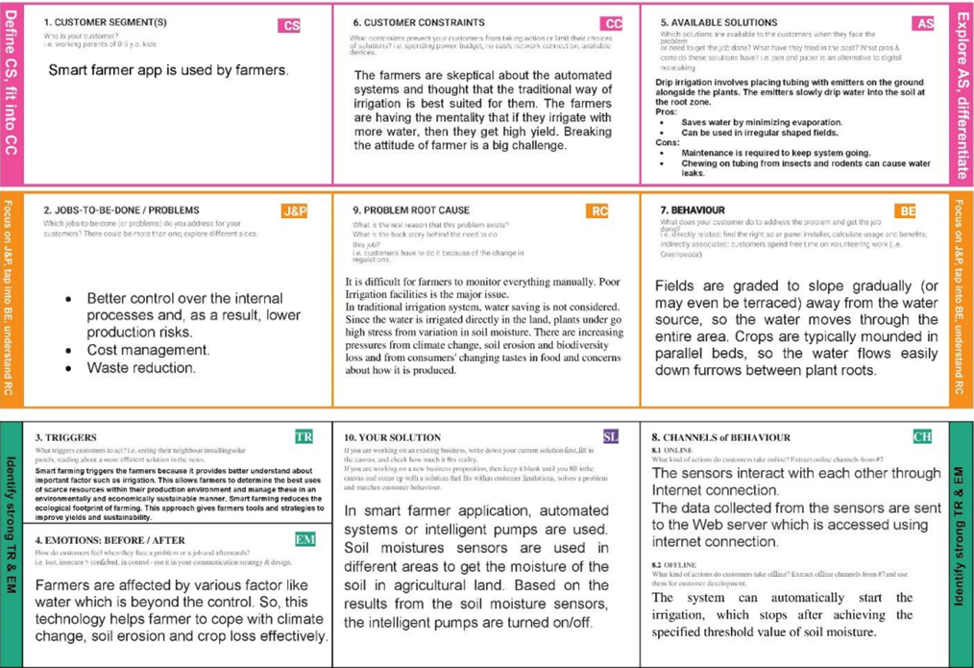

# REQUIREMENT ANALYSIS

## Functional requirement

|  |  |  |
| --- | --- | --- |
| **FR No.** | **Functional Requirement (Epic)** | **Sub Requirement (Story / Sub-Task)** |
| FR-1 | **User Registration** | Registration through Form Registration through Gmail |
| FR-2 | **User Confirmation** | Confirmation via Email Confirmation via OTP |
| FR-3 | **Sensor Function for framing System** | Measure the Temperature and Humidity Measure the Soil Monitoring Check the crop diseases |
| FR-4 | **Manage Modules** | Manage Roles of User Manage User permission |
| FR-5 | **Check whether details** | Temperature details Humidity details |
| FR-6 | **Data Management** | Manage the data of weather conditions Manage the data of crop conditions  Manage the data of live stock conditions |

## Non-Functional Requirements

|  |  |  |
| --- | --- | --- |
| **FR No.** | **Non- Functional**  **Requirement** | **Description** |
| NFR-1 | **Usability** | * User friendly guidelines for users to avail the features. * Most simplistic user interface for ease of use. |
| NFR-2 | **Security** | * All the details about the user are protected from unauthorized access. * Detection and identification of any misfunctions of sensors. |
| NFR-3 | **Reliability** | * Implementing Mesh IoT Networks * Building a Multi-layered defence for IoT Networks. |
| NFR-4 | **Performance** | The use of modern technology solutions helps to achieve the maximumperformances thus resulting in better quality and quantity yields. |
| NFR-5 | **Availability** | This app is available for all platforms |
| NFR-6 | **Scalability** | Scalability refers to the ability to increase available resources and system capability without the need to go through a major  system redesign or implementation. |

# PROJECT DESIGN

## Data flow diagrams

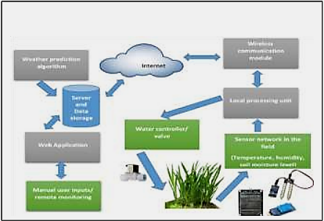 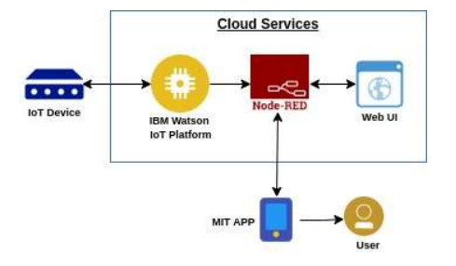

## Solution & Technical Architecture

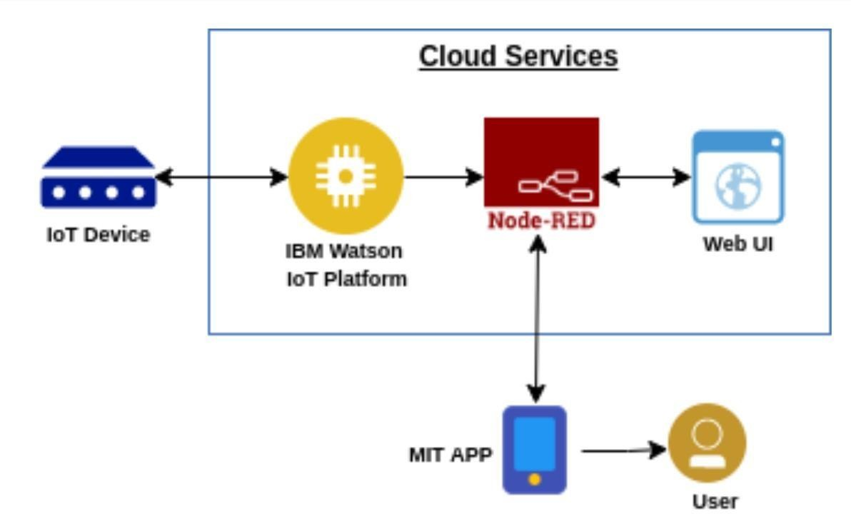 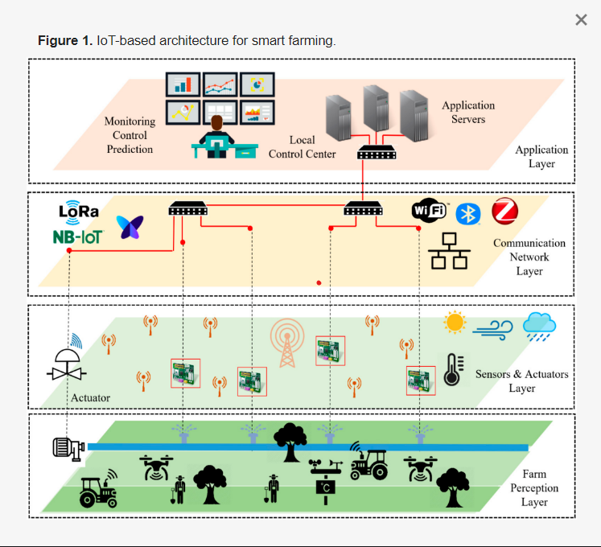

## User Stories

|  |  |  |  |  |  |  |
| --- | --- | --- | --- | --- | --- | --- |
| **User Type** | **Functional Requireme nt (Epic)** | **User Story Num**  **ber** | **User Story/ Task** | **Acceptance criteria** | **Priority** | **Release** |
| Custo mer ( Mobile user) | Registration | USN-1 | As a user,  I can register for th e application by entering my ema  il, password, and confirmingmyp  assword. | I can acce ssmy acc ount /das hboard | High | Sprint-1 |

|  |  |  |  |  |  |  |
| --- | --- | --- | --- | --- | --- | --- |
|  |  | USN-2 | As a user,  I will receive c onfirmation e mailonce I have registere d for the appli cation | I canrecei ve confir mationem ail& click confirm | High | Sprint-1 |
|  |  | USN-3 | As a user, I ca n register for t he application  through Gmail |  | Medium | Sprint-1 |
|  | Login | USN-4 | As a user, I ca nlog  into the applic ation byenteri ng  email &passw  ord |  | High | Sprint-1 |
| Custome r (Webus er) | Dashboard | USN-5 | As a User can view the dashboard, and this dashboard i nclude the chec kroles of access and then  move to the mana gemodules. | I can view the dashboar din this smart farming application system. | High | Sprint 2 |
|  |  | USN-6 | User canremotely access the motor  switch | In the smart farming app | High | Sprint 3 |
| Administr ator |  |  | As a  useronce view the manage  modules this describes the Manage system Admins andManage R oles  of User andec |  |  | Sprint 2 |

# PROJECT PLANNING & SCHEDULING

## Sprint Planning & Estimation

|  |  |  |  |  |  |  |
| --- | --- | --- | --- | --- | --- | --- |
| Sprint | Functional Requirement (Epic) | User Story Number | User Story /Task | Story Points | Priority | Team Member |
| Sprint-1 | Registration (Farmer Mobile User) | UNS-1 | As a user, I can register for the application by entering my email, password, and confirming my password. | 2 | High | Rajarajan L(Leader)  Pooja K  Hemalatha N  Austin Thatathil Alex |
| Sprint-1 | Login | UNS-2 | As a user, I will receive confirmation email once I have registered for the application | 1 | High | Rajarajan L(Leader)  Pooja K  Hemalatha N  Austin Thatathil Alex |
| Sprint-1 | Data Visualization | UNS-4 | As a user, I can register for the application through GMAIL | 2 | Medium | Rajarajan L(Leader)  Pooja K  Hemalatha N  Austin Thatathil Alex |
| Sprint-1 | Registration (Chemical Manufacturer - Web user) | UNS-1 | As a new user, I want to first register using my organization email and create a password for the account. | 2 | High | Rajarajan L(Leader)  Pooja K  Hemalatha N  Austin Thatathil Alex |
| Sprint-1 | Registration (Chemical Manufacturer - Mobile User) | UNS-1 | As a user, I want to first register using my email and create a password for the account. | 3 | High | Rajarajan L(Leader)  Pooja K  Hemalatha N  Austin Thatathil Alex |
| Sprint-1 | Login | UNS-2 | As a registered user, I need to easily log in to the application. | 2 | Low | Rajarajan L(Leader)  Pooja K  Hemalatha N  Austin Thatathil Alex |

|  |  |  |  |  |  |  |
| --- | --- | --- | --- | --- | --- | --- |
| Sprint-2 | User Interface | USN – 3 | As a user, I can register for the application through Facebook | 3 | Low | Rajarajan L(Leader)  Pooja K  Hemalatha N  Austin Thatathil Alex |
| Sprint-2 | Login | USN – 2 | As a registered user, I need to easily login log into my registered account via the web page in minimum time | 3 | High | Rajarajan L(Leader)  Pooja K  Hemalatha N  Austin Thatathil Alex |

|  |  |  |  |  |  |  |
| --- | --- | --- | --- | --- | --- | --- |
| Sprint-3 | Registration (Farmer -Web User) | USN – 1 | As a user, I can log into the application by entering email and password | 3 | High | Rajarajan L(Leader)  Pooja K  Hemalatha N  Austin Thatathil Alex |
| Sprint-3 | Web UI | USN – 3 | As a user, I need to have a user-friendly interface to easily view and access the resources. | 3 | Medium | Rajarajan L(Leader)  Pooja K  Hemalatha N  Austin Thatathil Alex |

|  |  |  |  |  |  |  |
| --- | --- | --- | --- | --- | --- | --- |
| Sprint - 4 | Login | USN – 2 | As a registered user, I need to easily log in using the registered account via the web page. |  | High | Rajarajan L(Leader)  Pooja K  Hemalatha N  Austin Thatathil Alex |
| Sprint - 4 | Web UI | USN – 3 | As a user, I need to have a friendly user interface to easily view and access the resources | 3 | Medium | Rajarajan L(Leader)  Pooja K  Hemalatha N  Austin Thatathil Alex |

## Sprint Delivery Schedule

|  |  |  |  |  |  |  |  |  |  |  |  |  |  |  |
| --- | --- | --- | --- | --- | --- | --- | --- | --- | --- | --- | --- | --- | --- | --- |
| Sprint | | Total Story Points | | | Duration | | Sprint Start Date | | Sprint end Date | | Story Points  Completed (as on Planned End Date) | | Sprint Release Date (Actual) | |
| Sprint-1 | | 12 | | | 6 Days | | 21 Oct 2022 | | 26 Oct 2022 | | 20 | | 26 Oct 2022 | |
| Sprint-2 | | 6 | | | 6 Days | | 28 Oct 2022 | | 2 Nov 2022 | | 20 | | 27 Oct 2022 | |
| Sprint-3 | | 6 | | | 6 Days | | 4 Nov 2022 | | 9 Nov 2022 | | 20 | | 3 Nov 2022 | |
| Sprint-4 | | 6 | | | 6 Days | | 11 Nov 2022 | | 16 Nov 2022 | | 20 | | 10 Nov 2022 | |
|  | |  |  | |  | |  | |  | |  | |

# CODING & SOLUTION

## Feature 1

Created a interface for the user to view the farm environment information using the MIT app inventor.

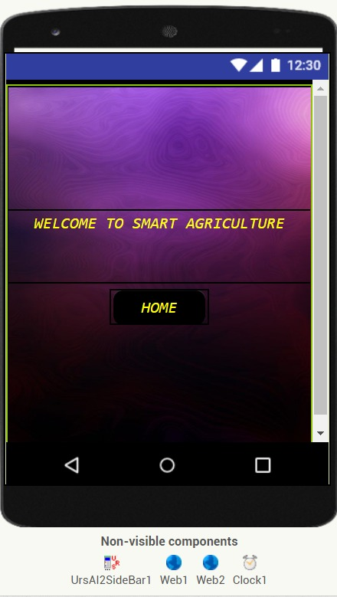

## Feature 2

implementation of the model integrated with cloud.

# TESTING

## Test Cases

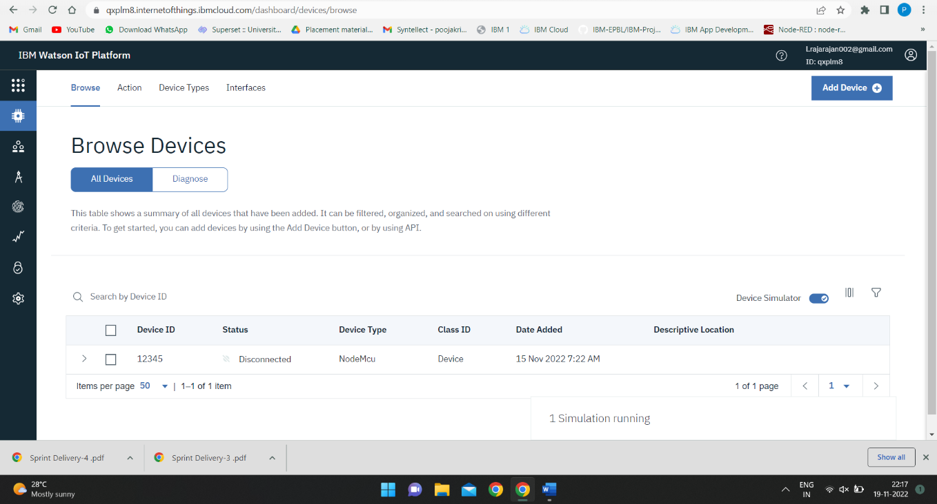

;' 29'( Haze

111-lf-2021

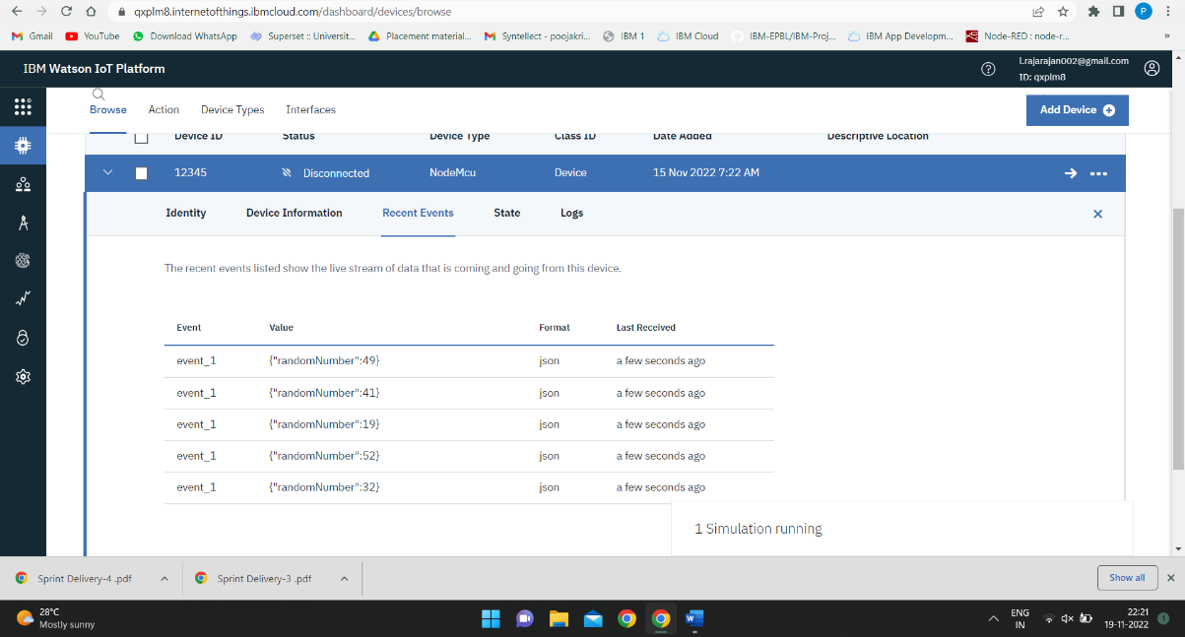  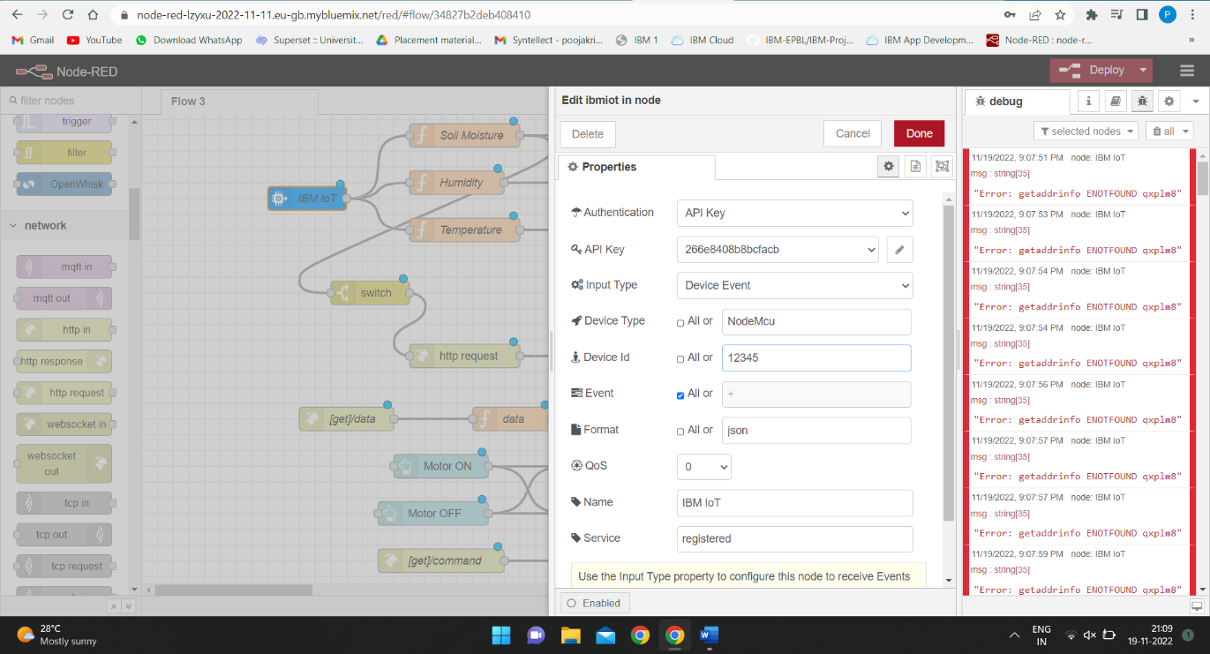

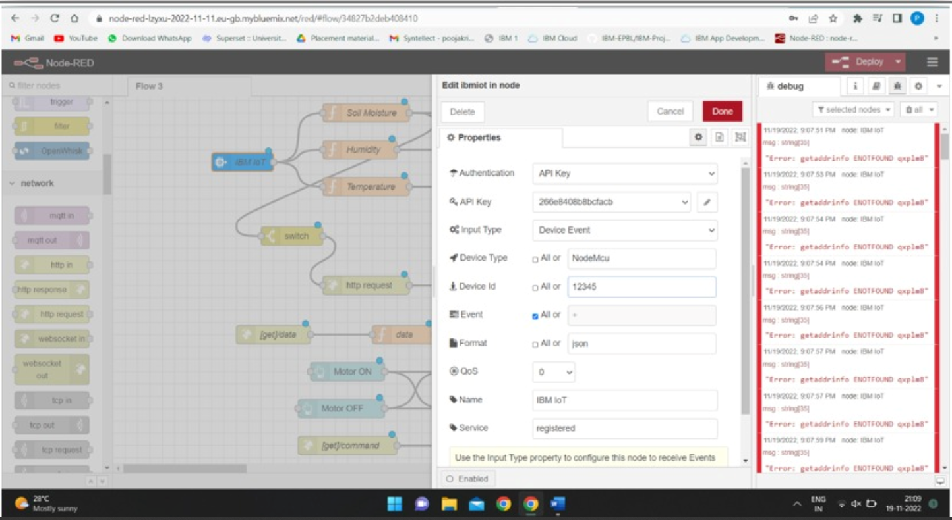

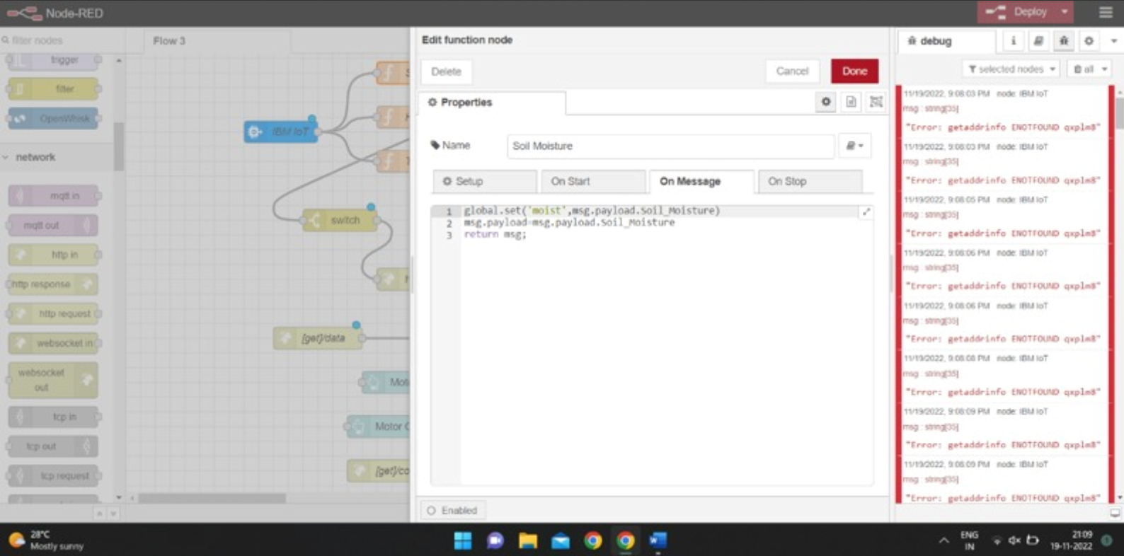

## User Accepting Testing

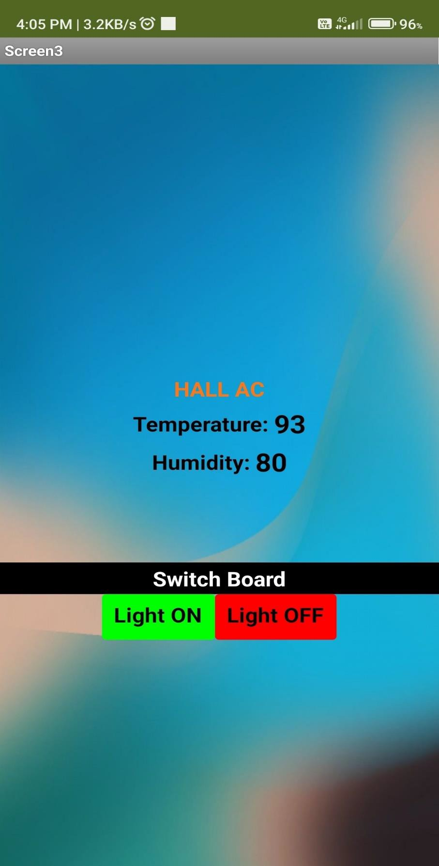

# 9.RESULTS

## Performance Metrics

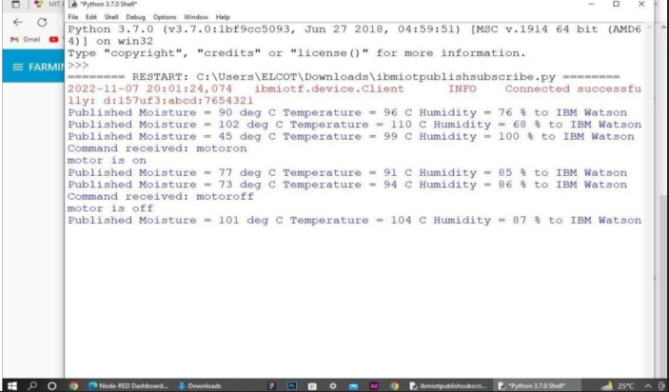

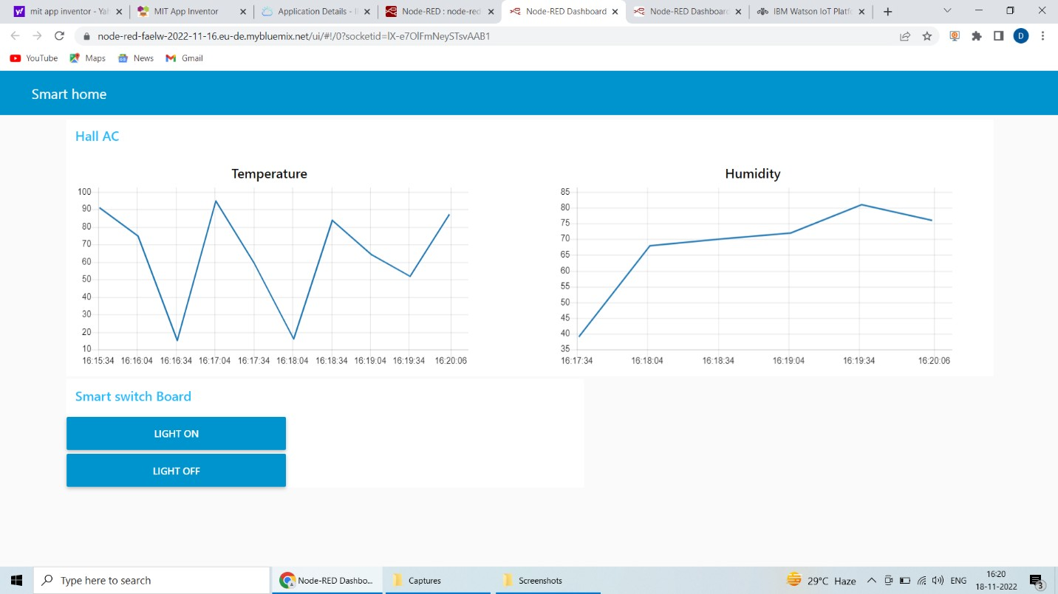

# ADVANTAGES & DISADVANTAGES

### Advantages

* 1. One of the main benefits of IoT systems in irrigation is associated with the lower water consumption.
  2. Also, most of the work related to irrigation is automated through such an approach, only the required amount of water is utilized for the irrigation process and lesser wastage takes place.

### Disadvantages

1. The primary disadvantage associated with a smart irrigation is the expense.
2. These systems can be quite costly depending on the size of the property.
3. Furthermore, portions of the lawn will have to be dug up to install pipework and attach it to the plumbing system of the home.

# CONCLUSION

Hence, the paper proposes an concept of mixing the state-of-the-art generation into the rural field to show the conventional methods of irrigation to modern methods for that reason making easy effective, and cost-effective cropping. some extent of automation is brought permitting the idea of tracking the sphere and the crop situations within a few lengthy-distance tiers using cloud offerings. the benefits like water saving and hard work-saving are initiated the usage of sensors that work automatically as they're programmed. Peoples are busy, they fail to spend time on them i.e what plant need like how much water is need for growth. this concept of modernization of agriculture is easy, low-cost and operable. for this reason, the paper proposes an idea of combining the modern generation into the agricultural subject to show the conventional strategies of irrigation to trendy strategies therefore making clean productive, and within your budget cropping. A few quantity of automation is added permitting the concept of tracking the sphere and the crop situations inside some lengthy-distance degrees using cloud offerings. the advantages like water saving and labor-saving are initiated the usage of sensors that paintings automatically as they're programmed. this concept of modernization of agriculture

is easy, inexpensive and operable.Through this project it can be concluded that there can be considerable development in farming with use of IoT and automation.Thus,the system is a potential solution to the problems faced in the existing manual and cumbersome process of irrigation by enabling efficient utilization of water resources.

## FUTURE SCOPE

Large ability of our indian agriculture is but untapped and we still have miles to tour in this arena of studies as we've specific soil textures in different areas of our kingdom. farmers may be benefitted through the real implementation of this projected software. real demanding situations that had been faced and which can be but to be triumph over in fact are the inter- networking of the nodes in an agricultural area and in designing a user pleasant software this is without difficulty comprehensible for the farmers.

# APPENDEX

## Source code

import time importsys

import ibmiotf.application

import ibmiotf. device

import random

#Provide your IBM Watson

Device Credentials organization = "qxplm8"

device Type = "NodeMcu"

deviceId = "12345"

authMethod = "auth-token"

authToken = ")22UmCJOV1XDNEs) BR"

# Initialize GPIO def myCommandCallback(cmd):

Print ("Command received: %s" % cmd.data['command']) status=cmd.data['command']

if status=="motor on":

print ("motor is on")

elif status == "motor off":

print ("motor is off")

else: print ("please send proper command")

try:

device Options = {"org": organization, "type": device Type, "id": deviceId, "auth-method": authMethod,

"auth-token": authToken}

DeviceCli = ibmiot. DeviceClient (déceptions)

#.............................................. except Exception as e:

deviceCli.connect()

while True:

#Get Sensor Data from DHT11

Temp=random. Randint (90,110)

Humid=random.randint(60,100)

Mois=random. Randint (20,120)

data = {'temp’: temp, 'Humid': Humid, ‘Mois’: Mois}

#Print data def myOnPublishCallback ():

print ("Published Temperature = %s C" % temp, "Humidity = %s %%" % Humid, “Moisture =%s deg c”

% Mois “to IBM Watson")

success = deviceCli.publishEvent("IoTSensor", "json", data, qos=0, onPublish=myOnPublishCallback)

if not success:

print ("Not connected to IoTF")

time. Sleep (10)

deviceCli.commandCallback = myCommandCallback # Disconnect the device and application from the

cloud deviceCli.disconnect()

## *Github Link*

<https://github.com/IBM-EPBL/IBM-Project-786-1658322723>

## *DEMO Link :*

<https://drive.google.com/file/d/1bMiBXdalUDYPRgDAaDQMAlFyqTECSYQv/view?usp=drivesdk>